WEB app proposal

Warehouse System

By:

Mr. Lê Quang Minh Anh

Co-founder and CTO of Fixie Corp.

Contact Info:

Email: [lequangminhanh@fixiecorp.com](mailto:lequangminhanh@fixiecorp.com)

Phone: +84 938 324 901

Prepared for:

Mr. Sơn

[nhoangson@hcmiu.edu.vn](mailto:nhoangson@hcmiu.edu.vn)

## Introduction

First of all, I want to thank you for taking the time to discuss your need for a warehouse web app.

Logistic-service web application development is serious business. It takes time and patience to create something that works and is free of bugs and other issues. The following proposal will include a summary of the process in my Web Application Planning and Development service.

Feel free to comment with any questions or concerns once you’ve had a chance to review this proposal. Once you’re ready to move forward with development of your custom Web application, simply let me know and we will start the development process.

# Project Description

The following services will be included in the development process.

• **Planning**

This including researching about audience engagement, framework compatibility, application journey map and user cases. These are the keys in app development

• **Design**

This process consists of designing visual prototype for the application. Creating User Experience and User Interface (UX and UI), Wireframes (structural core of the app), and class structure of the application’s functionality. Please kindly provide us with any content you already have in mind for the design (color schema, logo, layout,…)

When we agree on the design, the implementation of the application will begin.

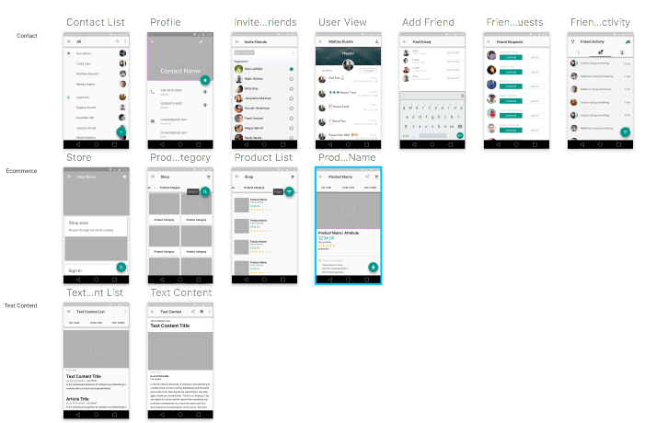

A sample of UX and UI prototype design.

• **Web App Development**

After the process of planning and designing the application prototype. We will focus on developing the web application. This process is the most vital and will be extremely careful.

For the FrontPage, it will be a simple static HTML page linked with PHP database, showing price range and product information.

The frameworks we use for the app will be based on PHP Backend interaction.

The specific information about the Dashboard of user is included below.

Also, Industry-level algorithm processing on the web is often a difficult task. We will deploy python scripting in the server to handle these unique algorithms.

• **Server Construction**

I don’t have much briefing about the server yet, so here is the best recommendation based on the requirement of the server (Fast connection for 500 users a year, Limit Downtime, Local-based service to avoid AAG cable problems) I will be using CMC Telecom for the cloud server and I will write the API myself. Please provide me details on how specific you want to construct the server or should you need further discussion in this matter.

• **User Dashboard Page**

According to my hypothesis. The admin page is a web page for user with full control of the flow of the product in the application. Also, a function to import and export shipment from and to the dashboard. The drag-n-drop canvas for drawing the warehouse will be implemented by a custom-made JavaScript Library. The path-finding function will be handled by the Python scripting in the backend of the application. Please provide me with any more functions you want the dashboard page to manage (Users interaction, etc…)

Delivery & Pricing

Quality takes time. Apps from the marketplace vary from two-week throwaways to years-long masterpieces. It is also notable that apps which target many features require more time to build than apps with a narrow scope.

After further calculation, the average time of completion for this project

will be around 3-6 months, 600+ hours.

Once we agree on the planning. An exact delivery time will be given and we will work with you to develop a detailed project schedule and begin the initial development stage.

**Initial Development Cost**

| **Name** | **Price** | **QTY** | **Subtotal** |
| --- | --- | --- | --- |
| PHP Front Page Implementation and Design (Logo, Styling,..) | 5,000,000 VND | 1 | 5,000,000 VND |
| Admin Dashboard Page Implementation | 20,000,000 VND | 1 | 20,000,000 VND |
| Server Hosting, Database and Backend Configuration | 10,000,000 VND | 1 | 10,000,000 VND |
| Path-finding and Canvas Drawing Functions | 25,000,000 VND | 1 | 25,000,000 VND |

**Total: 60,000,000 VND**

**2 Years Maintenance Cost Forecast**

| **Name** | **Price/year** | **Duration(years)** | **Subtotal** |
| --- | --- | --- | --- |
| Server Hosting from CMC Telecom Provider | 6,000,000 VND | 2 | 12,000,000 VND |
| Domain Name | 1,000,000 VND | 2 | 2,000,000 VND |
| Maintain fee | N/A | 0 | N/A |

**Total:14,000,000 VND**